Project Design Phase-II
Data Flow Diagram & User Stories

Date | 30 August 2026
Project Name | Automated Network Request Management
Maximum Marks | 4 Marks

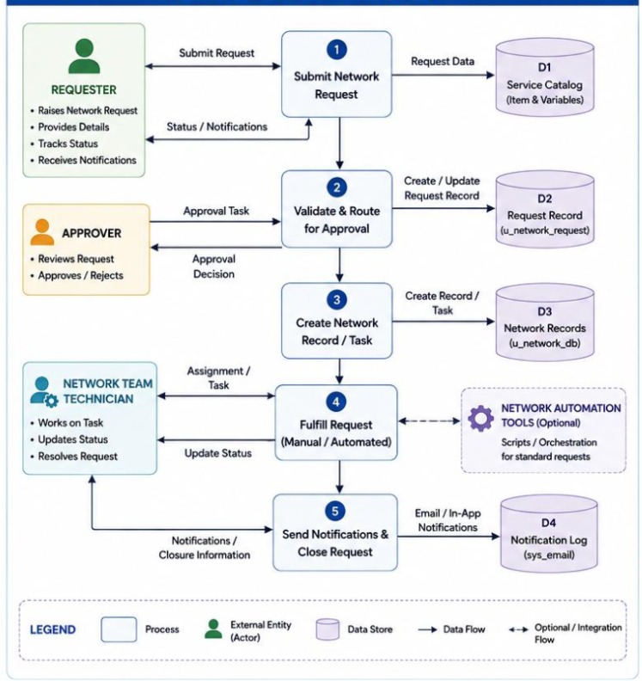

Data Flow Diagram
The requester submits a new network connection or relocation request with the required details. The system validates the request, creates the request record, and sends it to the approver for approval. Once approved, a task is created and assigned to the Network Team for fulfillment, after which the request status is updated. Finally, the system sends notifications to the requester and closes the request after successful completion.

User Stories
User Stories table specifically based on your Automated Network Request Management project, including New Connection and Network Relocation.

User Type | Functional Requirement (Epic) | User Story Number | User Story / Task | Acceptance criteria | Priority | Release
Employee / Requester) | Login & Access | USN-1 | As an employee, I can log in to the system using my credentials so that I can access the network request portal. | User can log in successfully and access the request dashboard. | High | Sprint-1
Employee / Requester | Network Request | USN-2 | As an employee, I can submit a request for a new network connection. | Request form accepts required details and creates a request record. | High | Sprint-1
Employee / Requester | Request Validation | USN-3 | As an employee, I can provide required information such as location, device type and contact details. | Mandatory fields are validated before submission. | High | Sprint-1
Employee / Requester | Request Tracking | USN-4 | As an employee, I can track the status of my network request. | User can view statuses such as New, Pending Approval, Approved, In Progress and Completed. | High | Sprint-1
Employee / Requester | Notifications | USN-5 | As an employee, I can receive notifications when my request status changes. | Email/system notification is sent for important status updates. | Medium | Sprint-2
Approver / Manager | Approval Management | USN-6 | As an approver, I can view network requests that require my approval. | Pending requests are displayed with complete request details. | High | Sprint-1
Approver / Manager | Request Approval | USN-7 | As an approver, I can approve or reject a network request. | Request status changes to Approved or Rejected after the action. | High | Sprint-1
IT Staff / Network Team |  | USN-8 | As IT staff, I can update the progress of a network request. | IT staff can update task/request status during implementation. | High | Sprint-1
  Network
  Implementation
Administrator | User Management | USN-9 | As an administrator, I can manage users and their roles. | Administrator can add, update, deactivate users and assign appropriate roles. | High | Sprint-1

